*Annie Williams*

*AT3 | 321541L*

*external task*

Website design and documentation

1. Investigating
2. Devising
3. Producing
4. Word dump
5. Annotated changes
6. Final products
7. Evaluation
8. Surveys
9. Bibliography

To understand what would work best and create the most interest for me when designing this website, i chose an issue that i am passionate about. From here i used some of my prior knowledge as well as did some research into what should be includes. From here i created the wireframes and started designing the contents of the website.

Wireframes

Website design process

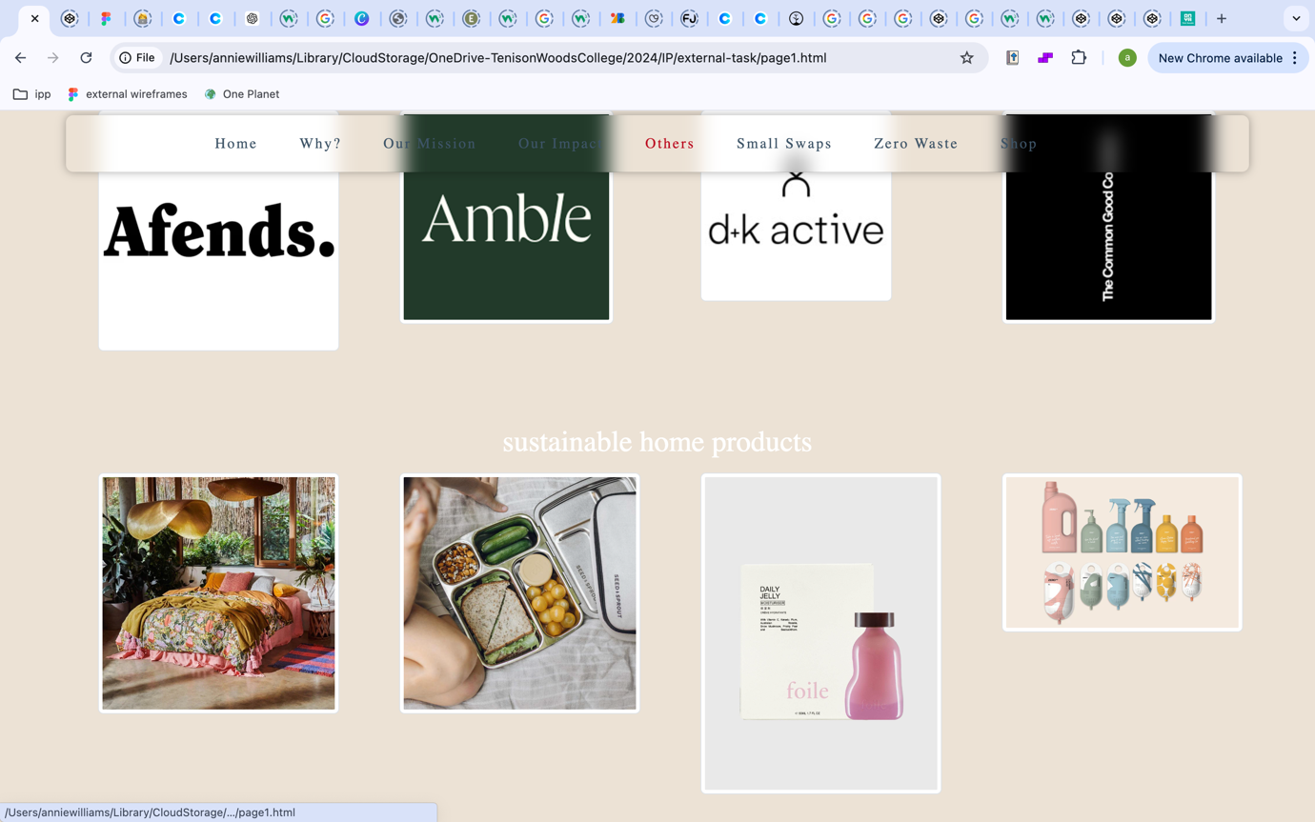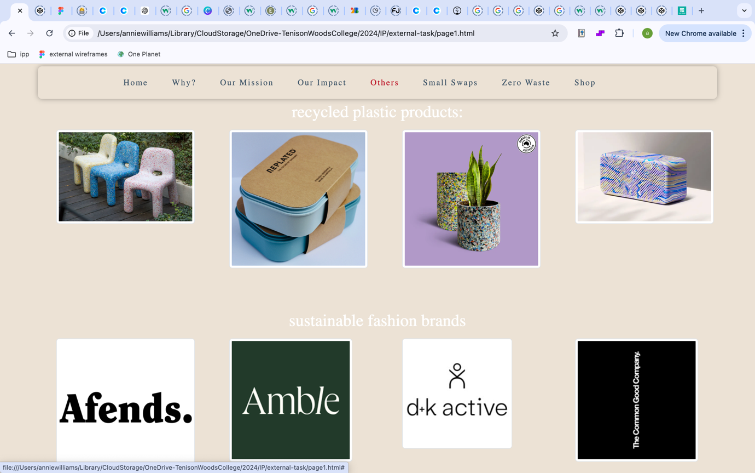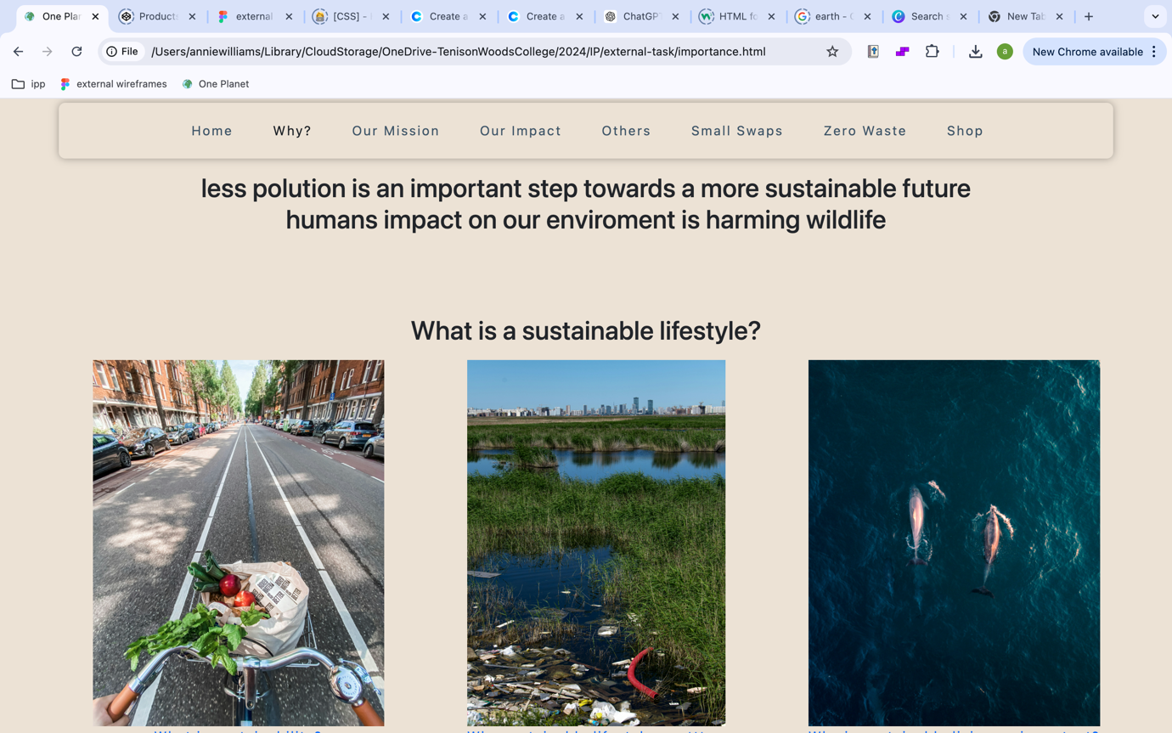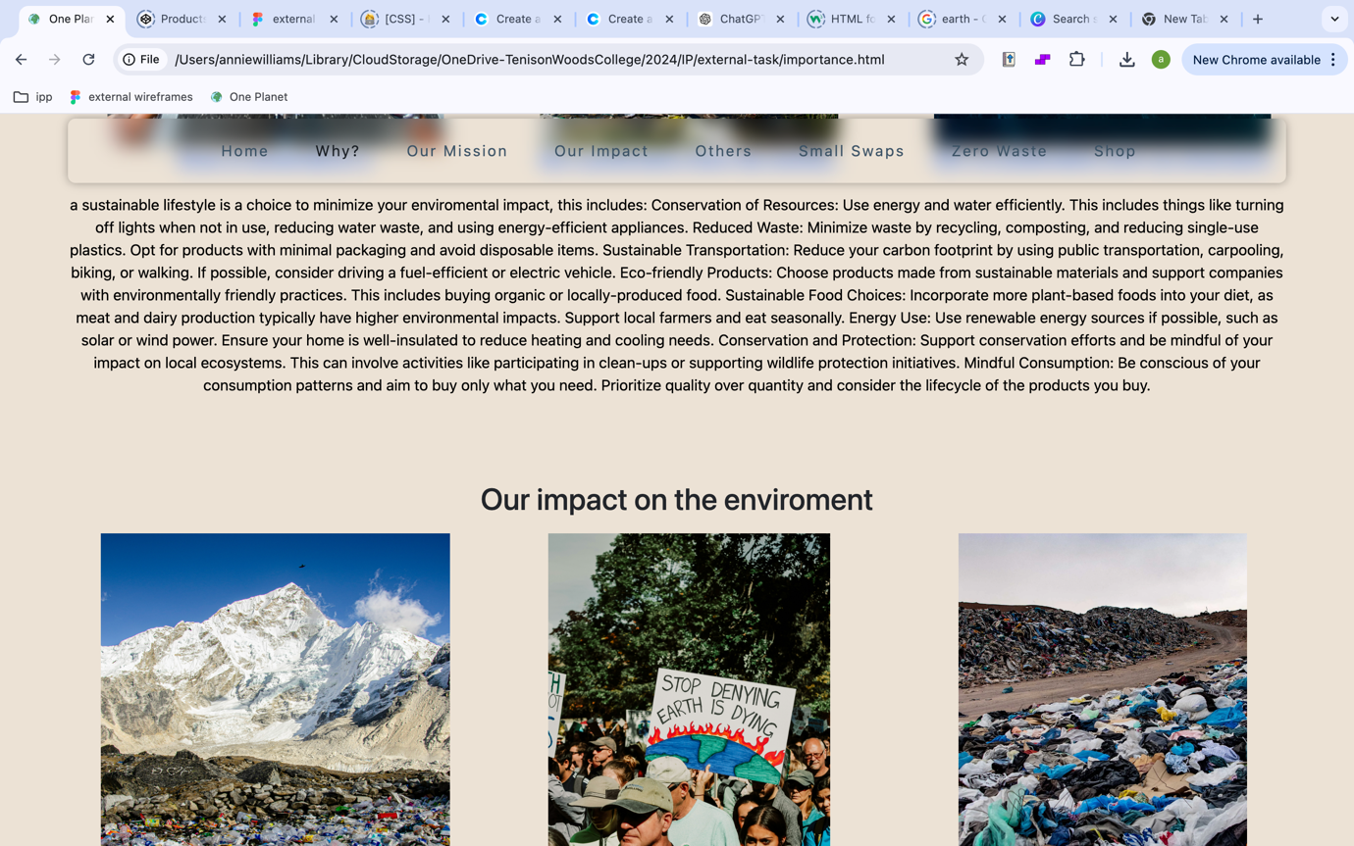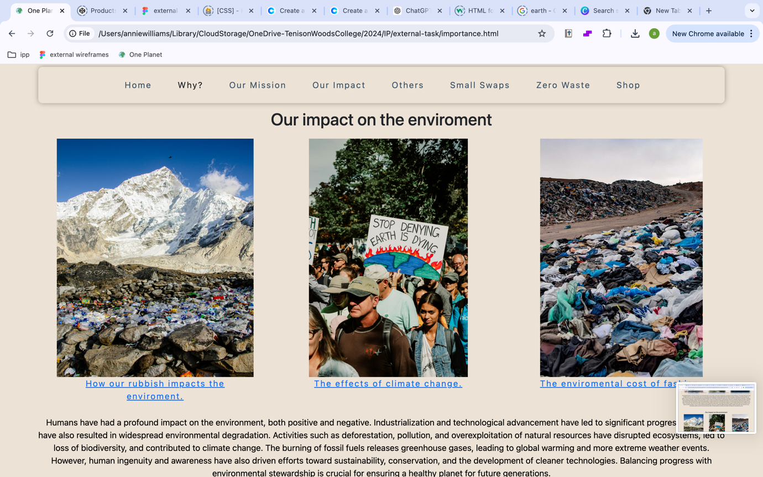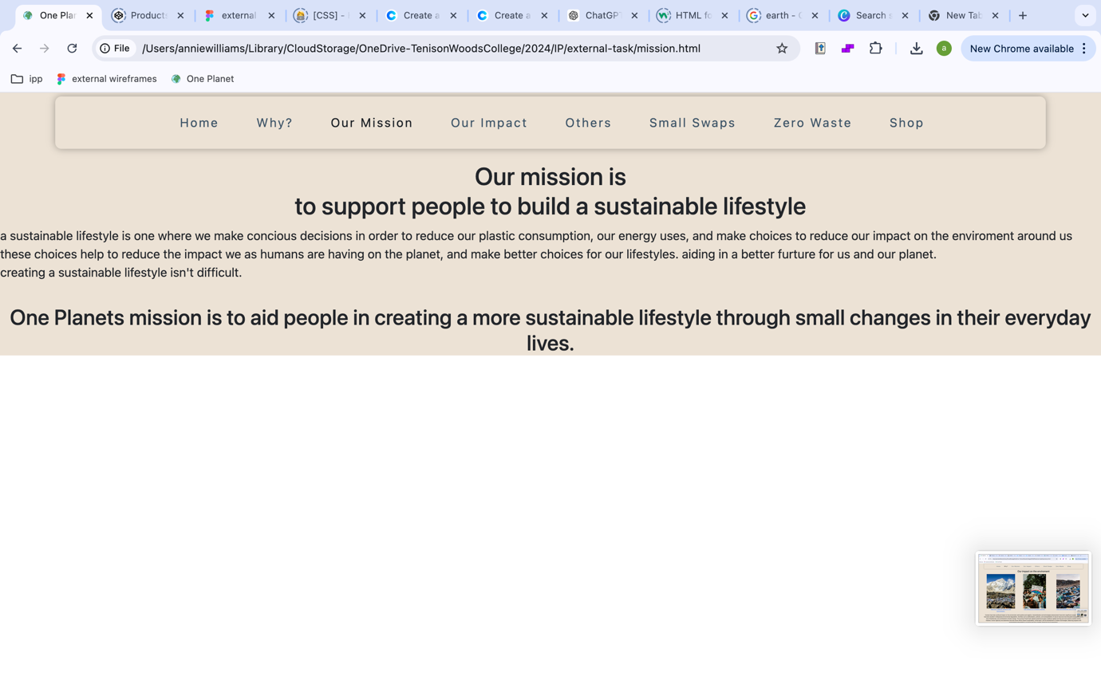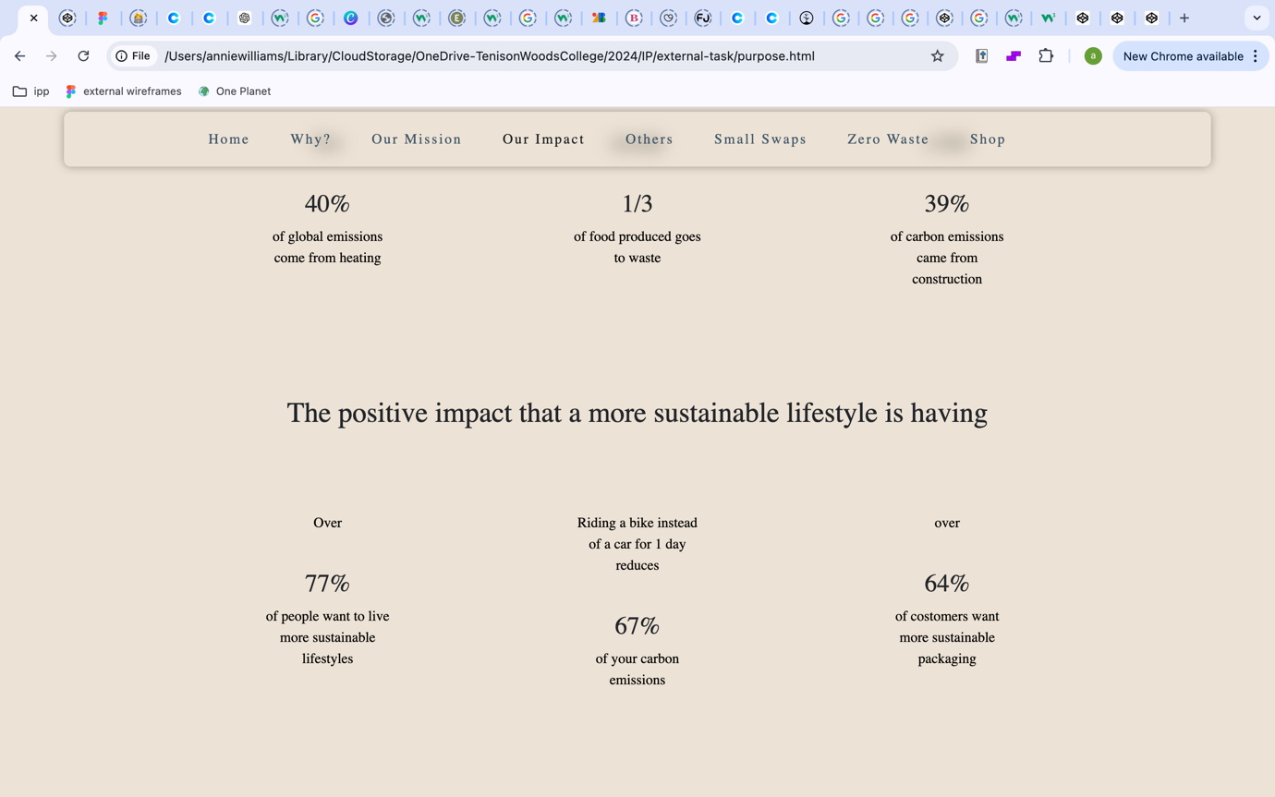

Original cards

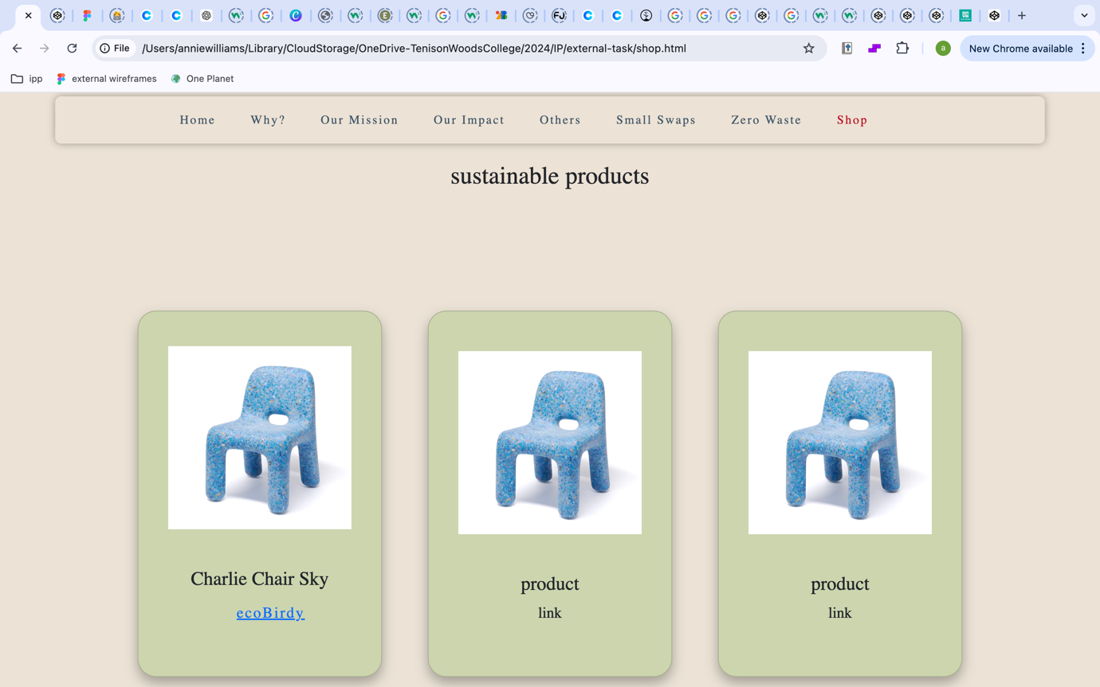

New cards

